**Mohammed Al Madhi**

**CIS 480**

**FALL 2020**

**Lab 4 - Cryptography**

|  |
| --- |
| * This is an assignment, and worth 2 points. * The due date is the same day midnight. It will be graded as pass/fail (2 or 0 points). |

Answer the following questions.

1. Were you able to crack the text encrypted with Caesar/Rot-13 using Analysis > Symmetric Encryption (classic)? ( Y / N )
2. How long did it take to brute force the key for the text encrypted with DES (ECB) when the last four hex codes of the key are not known?

**About 1 or 2 seconds**

1. How long did it take to brute force the key for the text encrypted with Reijndael (AES) when the last four hex codes of the key are not known?

It said around 35 minutes, but it was less than that.

1. Were you able to verify the digital signature? ( Y / N )

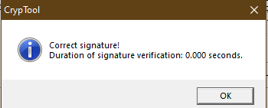

1. Are the hash values for CrypTool 1.4.41 (what you have calculated and the one on the cryptool.org website) the same? ( Yes / No )